**Azure Cloud Services 201**

**Azure Assignment_M1020091_Anitha Somanna**

**Azure Storage**

1. Write a template to create a Storage Account with SKU restrictions, encryption enabled and allow https access only.

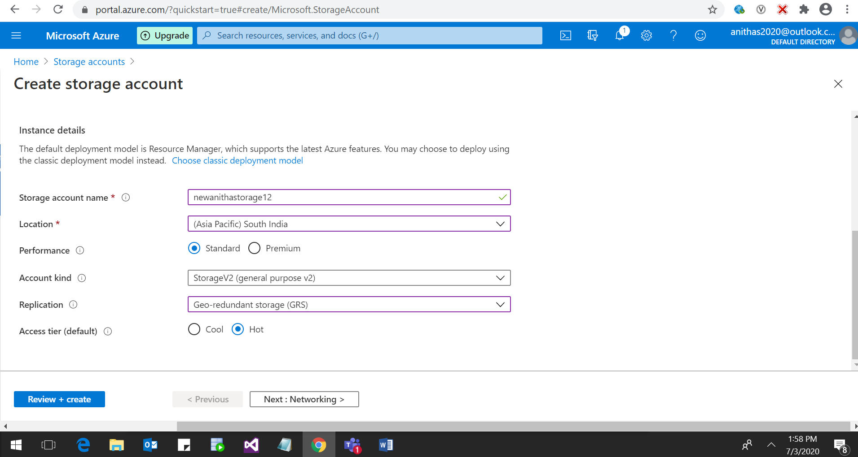

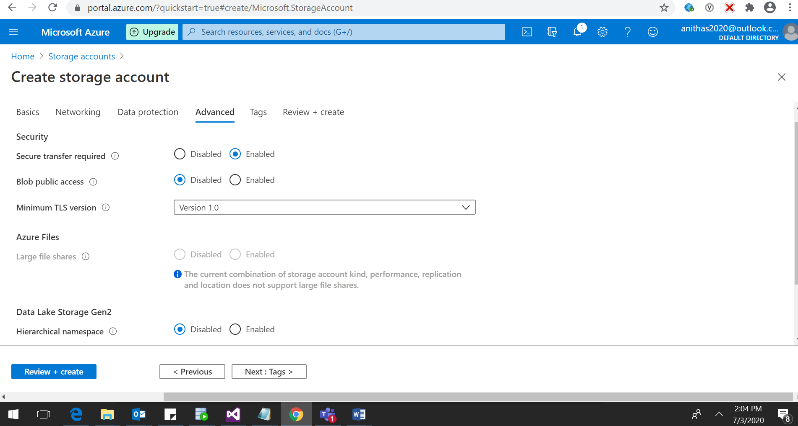

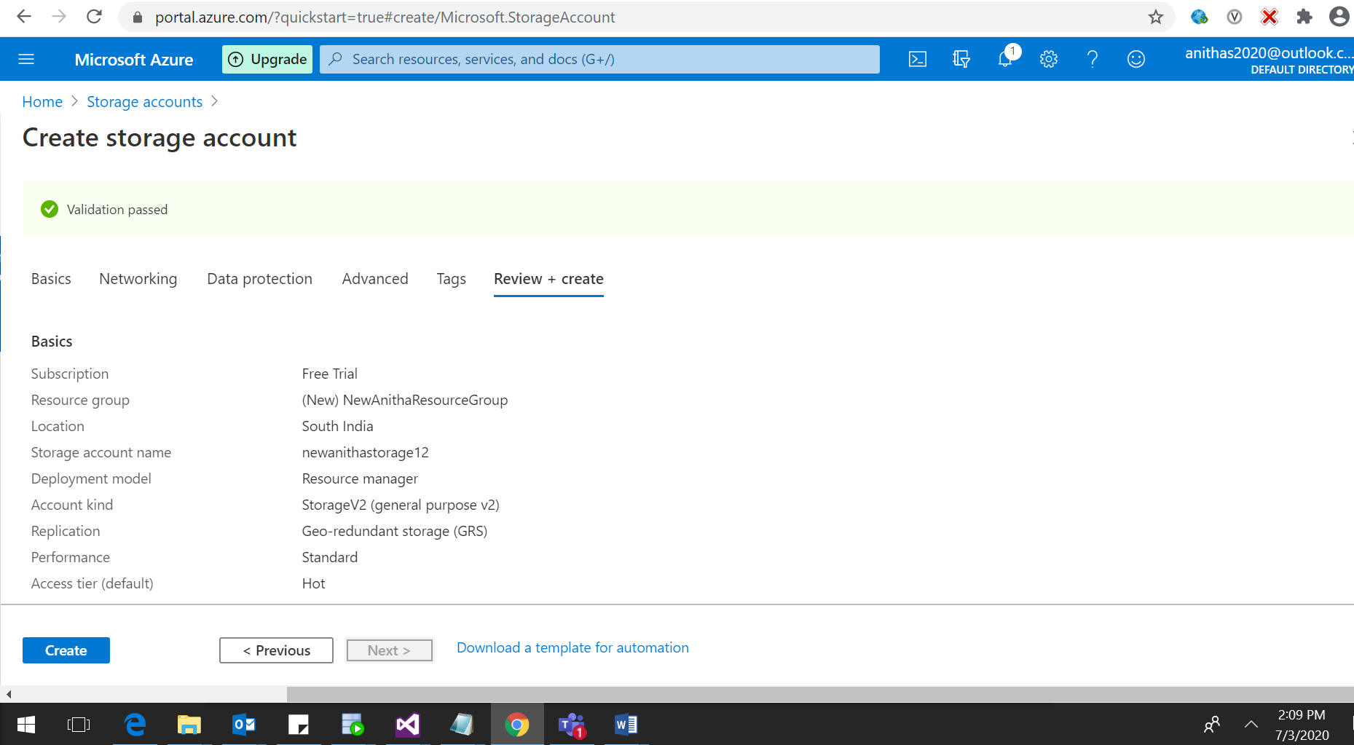

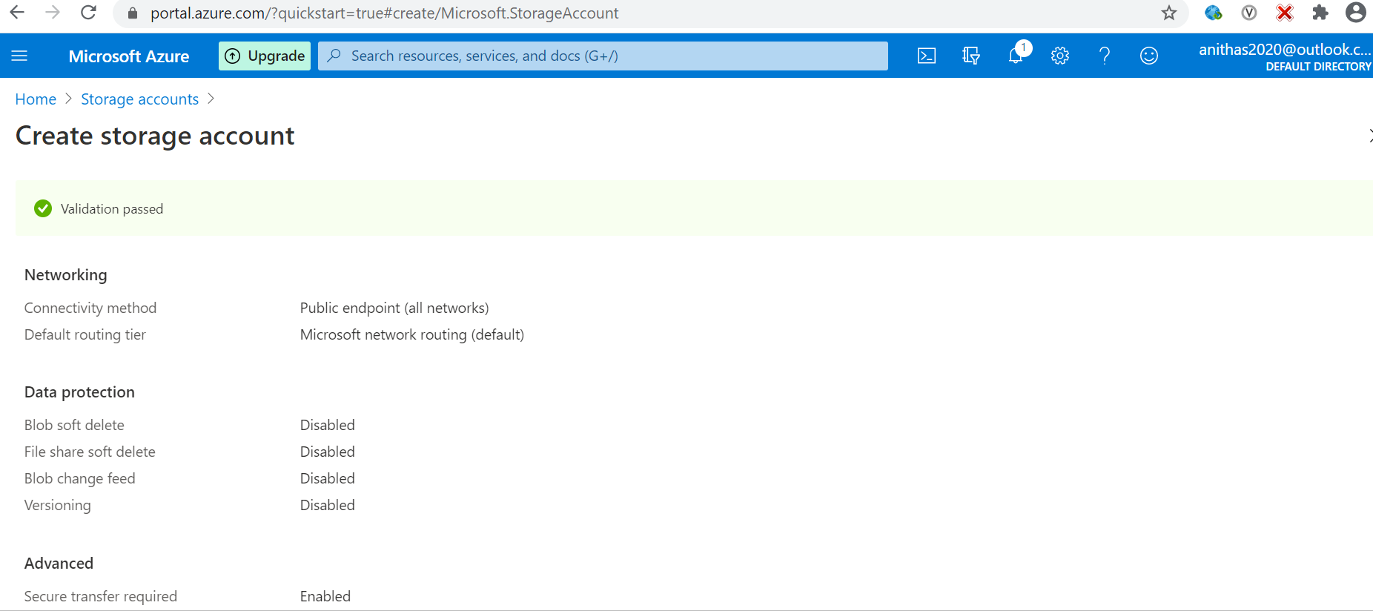

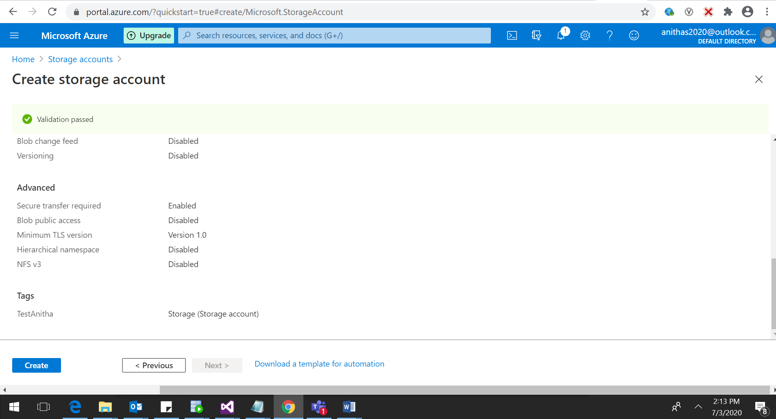

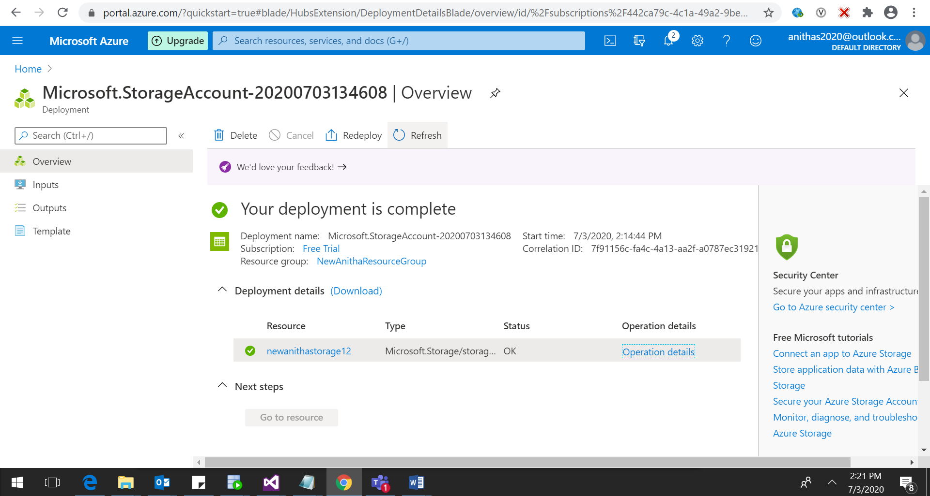

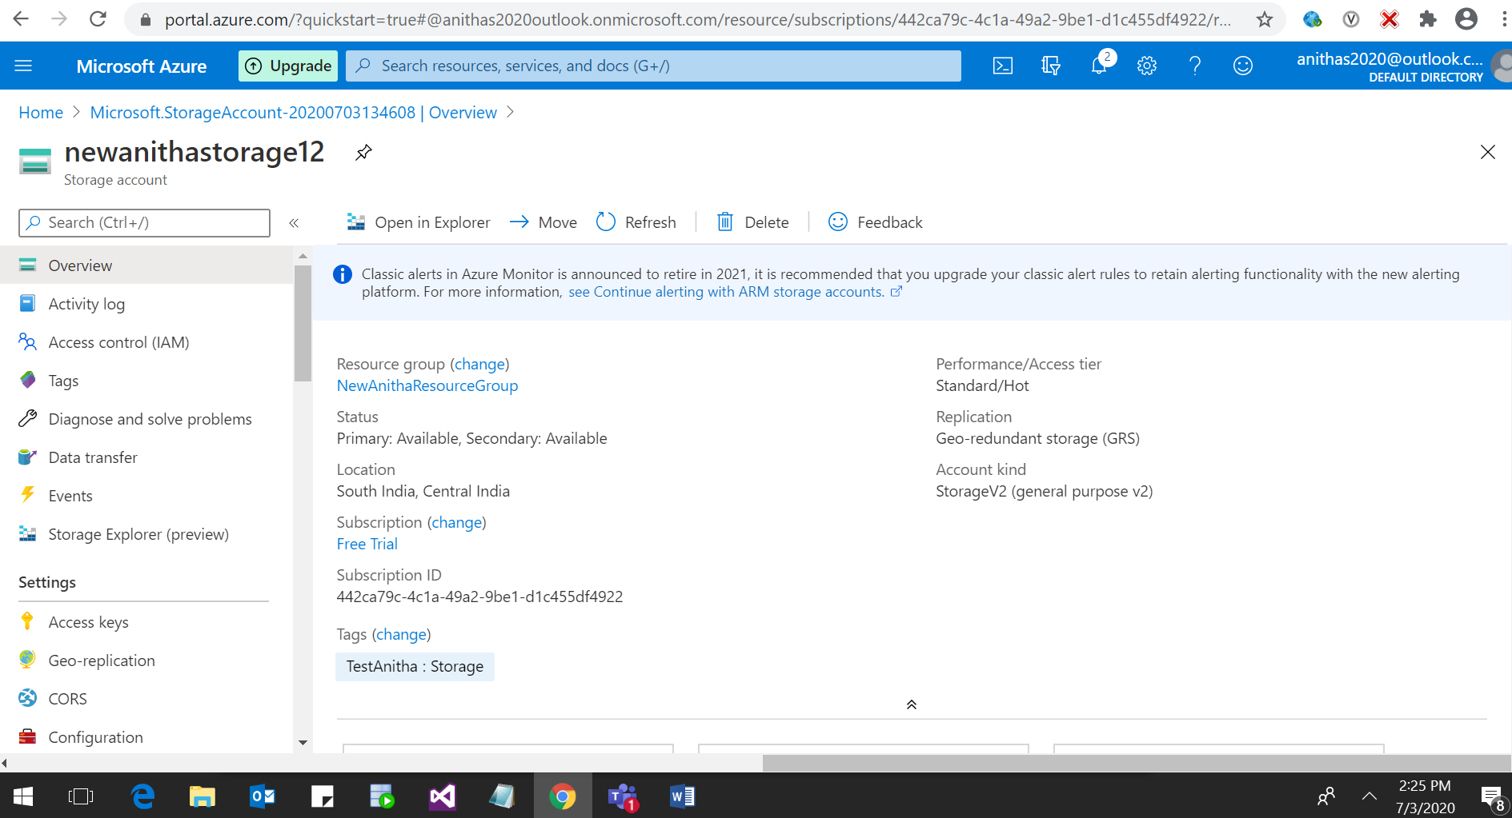

**Storage Account Creation Succeeded**

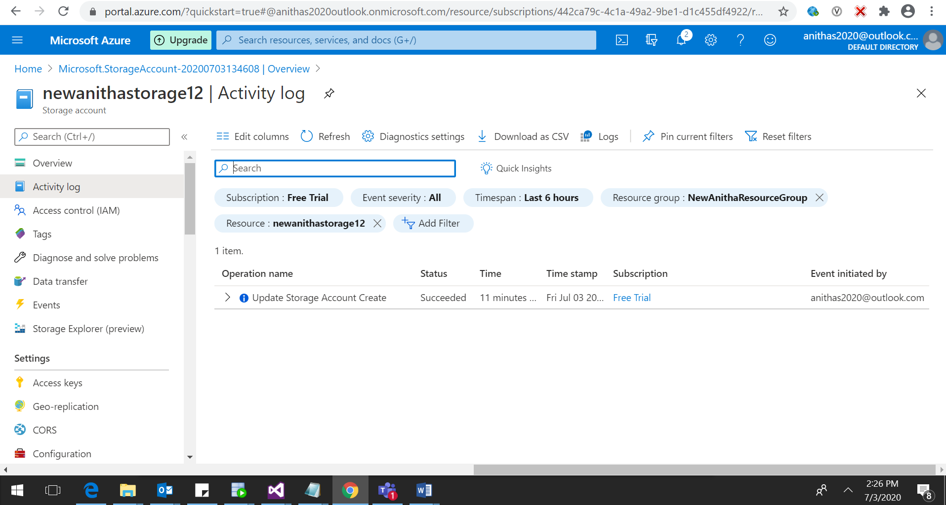

**SKU enabled screen shot below for reference.**

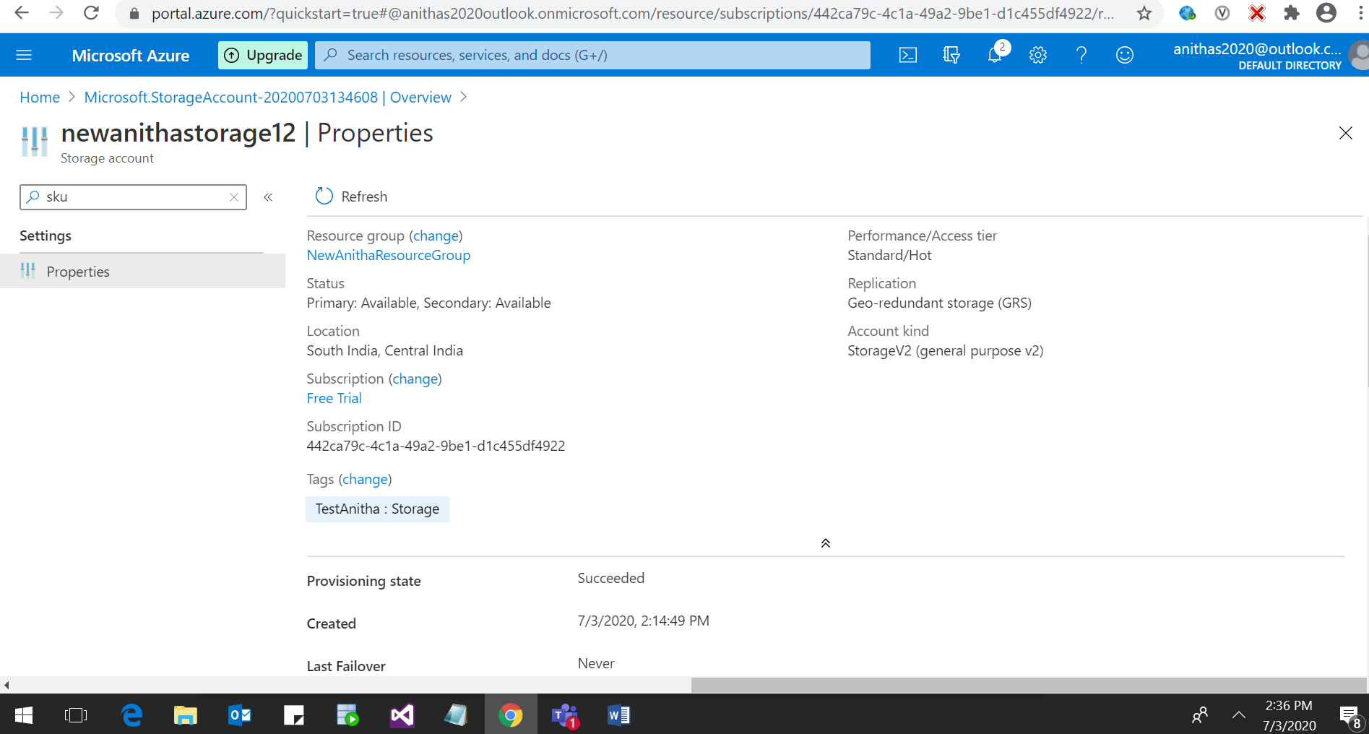

**HTTPS Enabled, screen shot below for reference.**



**Encryption Enabled for Storage Account Created, screen shot below for reference.**

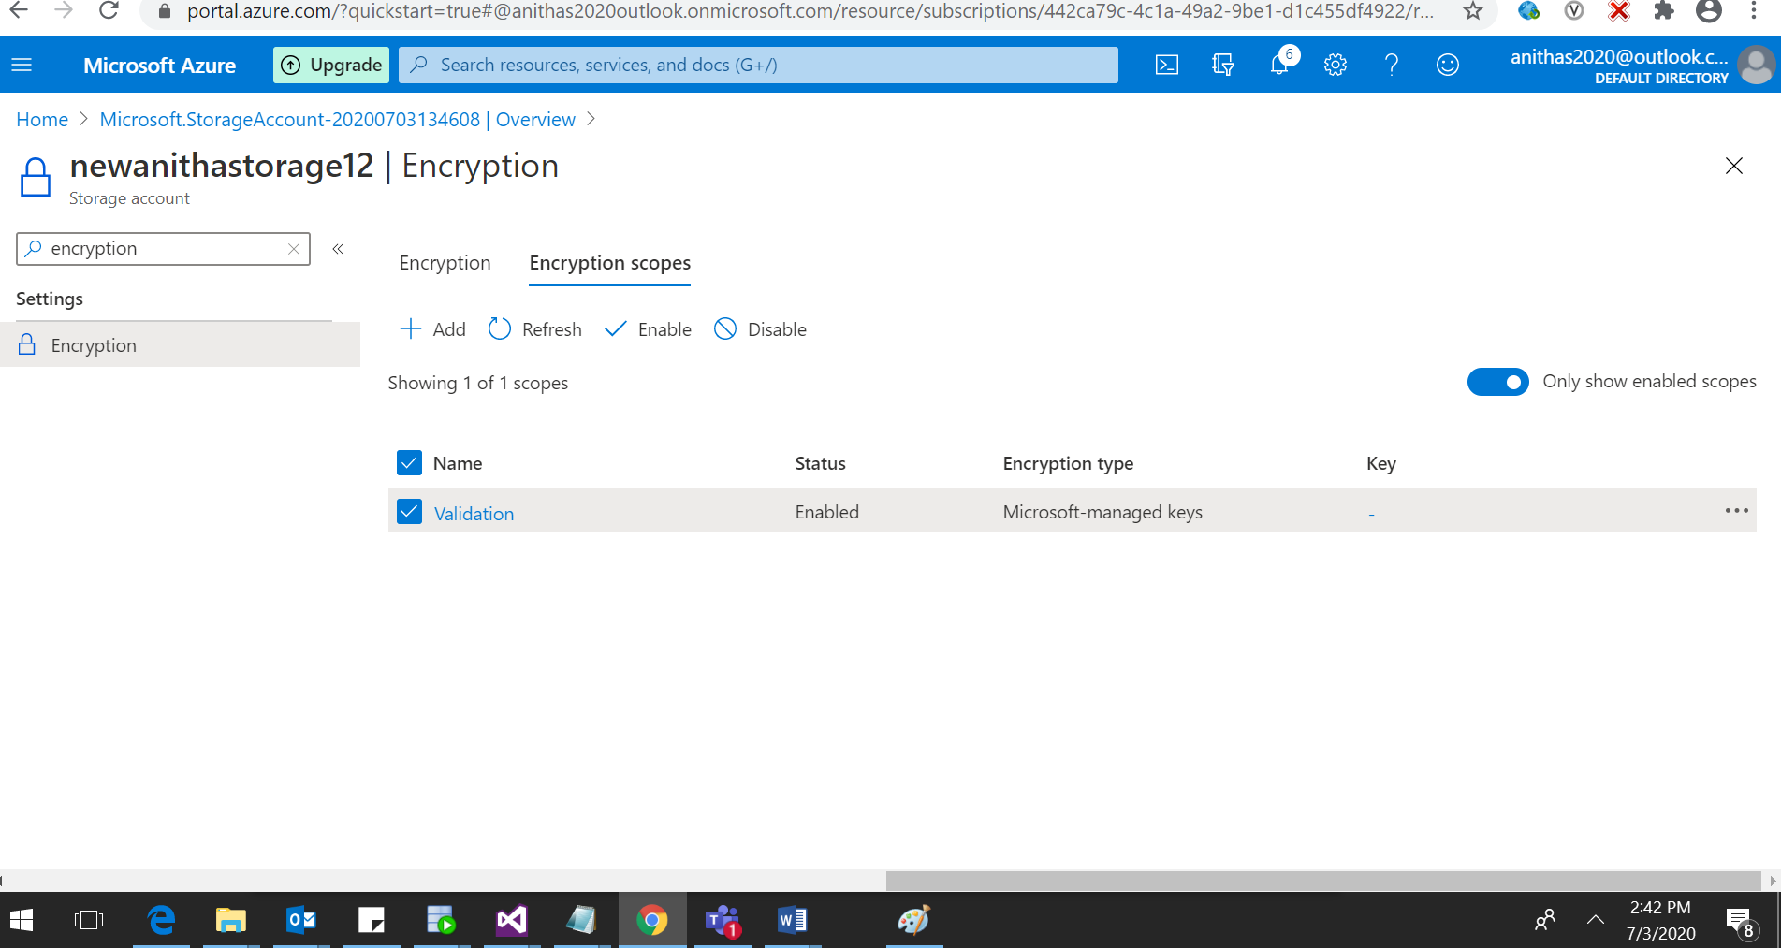

**Azure Virtual Networks and Virtual Machines**

1. Create an ARM Template for a virtual network with subnets and Network Security Group with Inbound Outbound rules

2. Write an ARM Template to deploy a windows VM using the existing VNets and NSGs

3. Deploy an application in the VM and access using the public IP

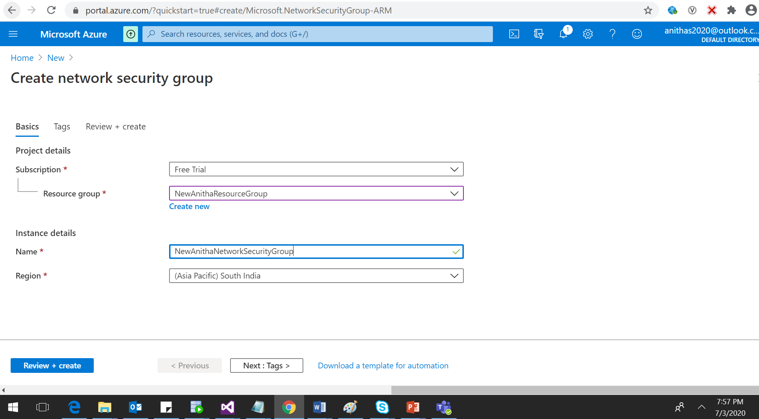

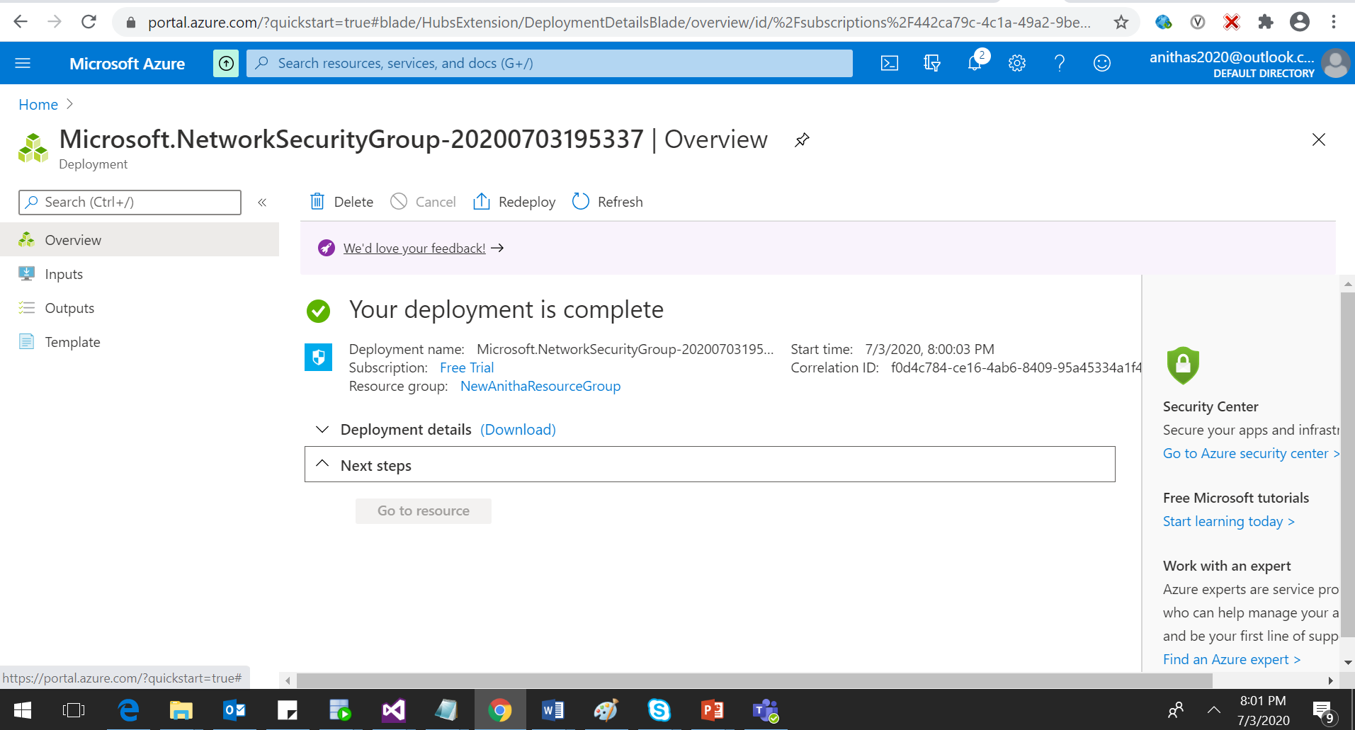

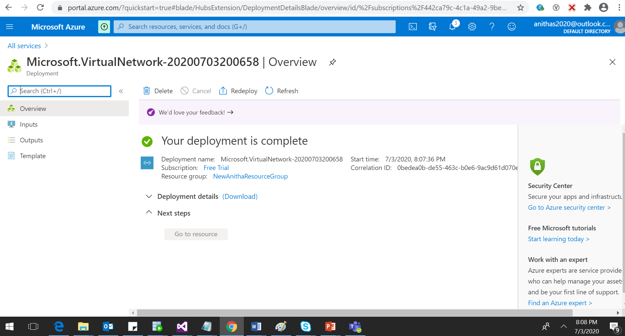

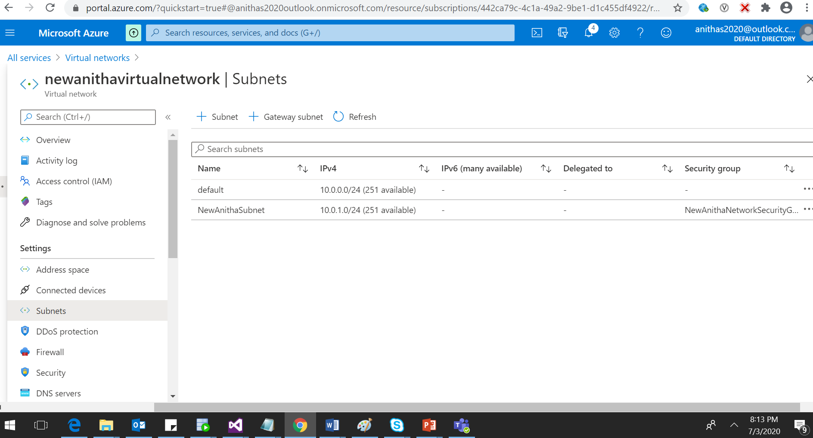

1. ARM Template for a virtual network with subnets and Network Security Group with Inbound Outbound rules. Screen shot below for reference.

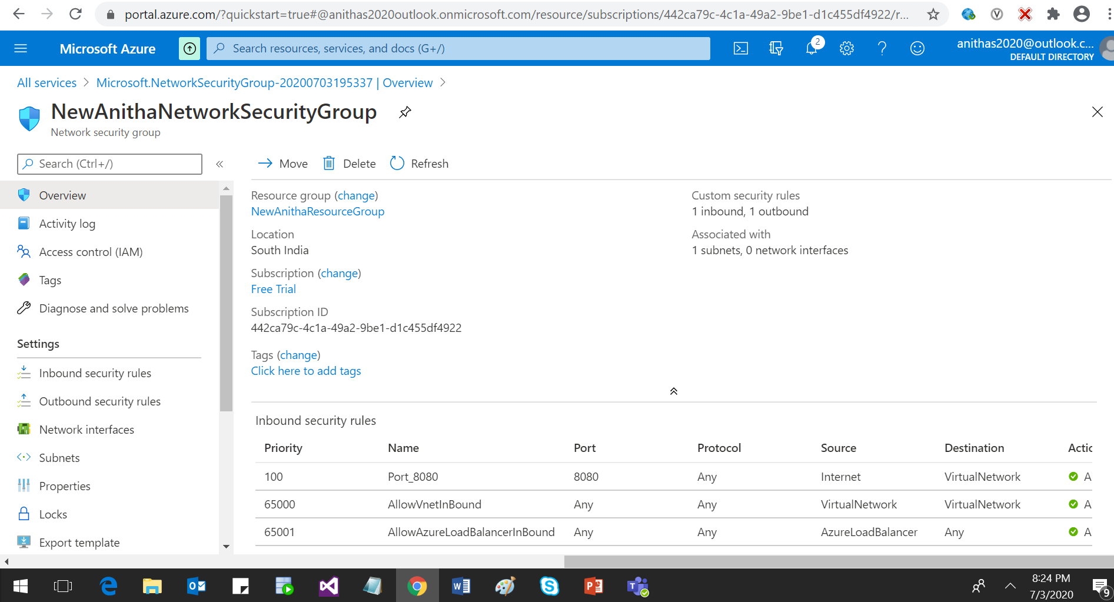

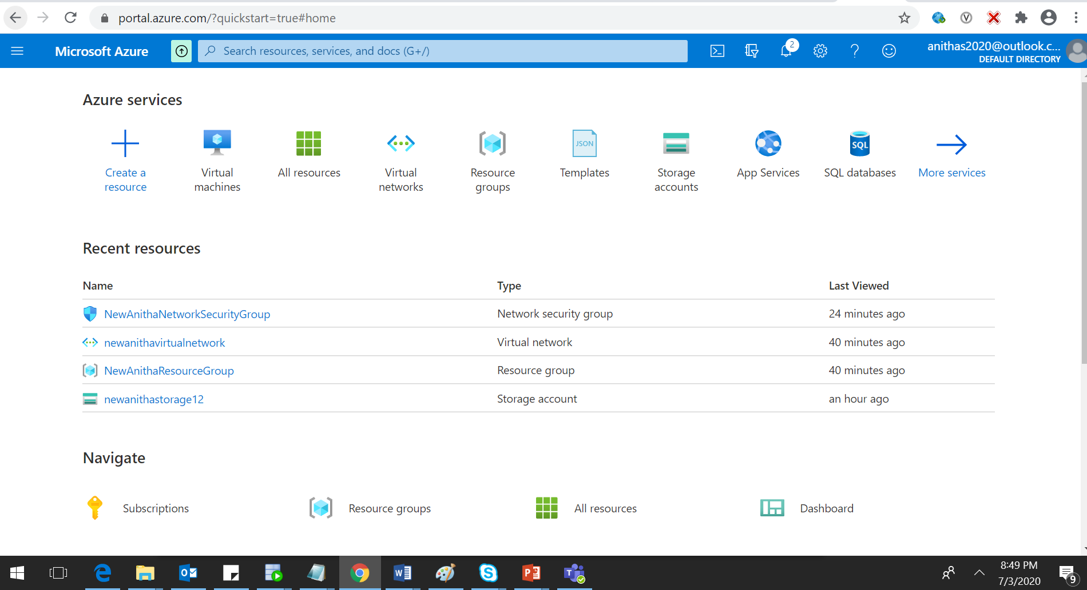

Write an ARM Template to deploy a windows VM using the existing VNets and NSGs

{

"$schema": "https://schema.management.azure.com/schemas/2015-01-01/deploymentTemplate.json#",

"contentVersion": "1.0.0.0",

"parameters": {

"storageAccounts_newanithastorage12_name": {

"defaultValue": "newanithastorage12",

"type": "String"

},

"virtualNetworks_newanithavirtualnetwork_name": {

"defaultValue": "newanithavirtualnetwork",

"type": "String"

},

"networkSecurityGroups_NewAnithaNetworkSecurityGroup_name": {

"defaultValue": "NewAnithaNetworkSecurityGroup",

"type": "String"

}

},

"variables": {},

"resources": [

{

"type": "Microsoft.Network/networkSecurityGroups",

"apiVersion": "2020-04-01",

"name": "[parameters('networkSecurityGroups_NewAnithaNetworkSecurityGroup_name')]",

"location": "southindia",

"properties": {

"securityRules": [

{

"name": "Port_8080",

"properties": {

"protocol": "*",

"sourcePortRange": "*",

"destinationPortRange": "8080",

"sourceAddressPrefix": "Internet",

"destinationAddressPrefix": "VirtualNetwork",

"access": "Allow",

"priority": 100,

"direction": "Inbound",

"sourcePortRanges": [],

"destinationPortRanges": [],

"sourceAddressPrefixes": [],

"destinationAddressPrefixes": []

}

},

{

"name": "Outbound_8080",

"properties": {

"protocol": "*",

"sourcePortRange": "*",

"destinationPortRange": "8080",

"sourceAddressPrefix": "VirtualNetwork",

"destinationAddressPrefix": "Internet",

"access": "Allow",

"priority": 100,

"direction": "Outbound",

"sourcePortRanges": [],

"destinationPortRanges": [],

"sourceAddressPrefixes": [],

"destinationAddressPrefixes": []

}

}

]

}

},

{

"type": "Microsoft.Storage/storageAccounts",

"apiVersion": "2019-06-01",

"name": "[parameters('storageAccounts_newanithastorage12_name')]",

"location": "southindia",

"tags": {

"TestAnitha": "Storage"

},

"sku": {

"name": "Standard_GRS",

"tier": "Standard"

},

"kind": "StorageV2",

"properties": {

"networkAcls": {

"bypass": "AzureServices",

"virtualNetworkRules": [],

"ipRules": [],

"defaultAction": "Allow"

},

"supportsHttpsTrafficOnly": true,

"encryption": {

"services": {

"file": {

"keyType": "Account",

"enabled": true

},

"blob": {

"keyType": "Account",

"enabled": true

}

},

"keySource": "Microsoft.Storage"

},

"accessTier": "Hot"

}

},

{

"type": "Microsoft.Network/networkSecurityGroups/securityRules",

"apiVersion": "2020-04-01",

"name": "[concat(parameters('networkSecurityGroups_NewAnithaNetworkSecurityGroup_name'), '/Outbound_8080')]",

"dependsOn": [

"[resourceId('Microsoft.Network/networkSecurityGroups', parameters('networkSecurityGroups_NewAnithaNetworkSecurityGroup_name'))]"

],

"properties": {

"protocol": "*",

"sourcePortRange": "*",

"destinationPortRange": "8080",

"sourceAddressPrefix": "VirtualNetwork",

"destinationAddressPrefix": "Internet",

"access": "Allow",

"priority": 100,

"direction": "Outbound",

"sourcePortRanges": [],

"destinationPortRanges": [],

"sourceAddressPrefixes": [],

"destinationAddressPrefixes": []

}

},

{

"type": "Microsoft.Network/networkSecurityGroups/securityRules",

"apiVersion": "2020-04-01",

"name": "[concat(parameters('networkSecurityGroups_NewAnithaNetworkSecurityGroup_name'), '/Port_8080')]",

"dependsOn": [

"[resourceId('Microsoft.Network/networkSecurityGroups', parameters('networkSecurityGroups_NewAnithaNetworkSecurityGroup_name'))]"

],

"properties": {

"protocol": "*",

"sourcePortRange": "*",

"destinationPortRange": "8080",

"sourceAddressPrefix": "Internet",

"destinationAddressPrefix": "VirtualNetwork",

"access": "Allow",

"priority": 100,

"direction": "Inbound",

"sourcePortRanges": [],

"destinationPortRanges": [],

"sourceAddressPrefixes": [],

"destinationAddressPrefixes": []

}

},

{

"type": "Microsoft.Network/virtualNetworks",

"apiVersion": "2020-04-01",

"name": "[parameters('virtualNetworks_newanithavirtualnetwork_name')]",

"location": "southindia",

"dependsOn": [

"[resourceId('Microsoft.Network/networkSecurityGroups', parameters('networkSecurityGroups_NewAnithaNetworkSecurityGroup_name'))]"

],

"properties": {

"addressSpace": {

"addressPrefixes": [

"10.0.0.0/16"

]

},

"subnets": [

{

"name": "default",

"properties": {

"addressPrefix": "10.0.0.0/24",

"delegations": [],

"privateEndpointNetworkPolicies": "Enabled",

"privateLinkServiceNetworkPolicies": "Enabled"

}

},

{

"name": "NewAnithaSubnet",

"properties": {

"addressPrefix": "10.0.1.0/24",

"networkSecurityGroup": {

"id": "[resourceId('Microsoft.Network/networkSecurityGroups', parameters('networkSecurityGroups_NewAnithaNetworkSecurityGroup_name'))]"

},

"serviceEndpoints": [],

"delegations": [],

"privateEndpointNetworkPolicies": "Enabled",

"privateLinkServiceNetworkPolicies": "Enabled"

}

}

],

"virtualNetworkPeerings": [],

"enableDdosProtection": false,

"enableVmProtection": false

}

},

{

"type": "Microsoft.Network/virtualNetworks/subnets",

"apiVersion": "2020-04-01",

"name": "[concat(parameters('virtualNetworks_newanithavirtualnetwork_name'), '/default')]",

"dependsOn": [

"[resourceId('Microsoft.Network/virtualNetworks', parameters('virtualNetworks_newanithavirtualnetwork_name'))]"

],

"properties": {

"addressPrefix": "10.0.0.0/24",

"delegations": [],

"privateEndpointNetworkPolicies": "Enabled",

"privateLinkServiceNetworkPolicies": "Enabled"

}

},

{

"type": "Microsoft.Storage/storageAccounts/blobServices",

"apiVersion": "2019-06-01",

"name": "[concat(parameters('storageAccounts_newanithastorage12_name'), '/default')]",

"dependsOn": [

"[resourceId('Microsoft.Storage/storageAccounts', parameters('storageAccounts_newanithastorage12_name'))]"

],

"sku": {

"name": "Standard_GRS",

"tier": "Standard"

},

"properties": {

"cors": {

"corsRules": []

},

"deleteRetentionPolicy": {

"enabled": false

}

}

},

{

"type": "Microsoft.Storage/storageAccounts/fileServices",

"apiVersion": "2019-06-01",

"name": "[concat(parameters('storageAccounts_newanithastorage12_name'), '/default')]",

"dependsOn": [

"[resourceId('Microsoft.Storage/storageAccounts', parameters('storageAccounts_newanithastorage12_name'))]"

],

"sku": {

"name": "Standard_GRS",

"tier": "Standard"

},

"properties": {

"cors": {

"corsRules": []

}

}

},

{

"type": "Microsoft.Network/virtualNetworks/subnets",

"apiVersion": "2020-04-01",

"name": "[concat(parameters('virtualNetworks_newanithavirtualnetwork_name'), '/NewAnithaSubnet')]",

"dependsOn": [

"[resourceId('Microsoft.Network/virtualNetworks', parameters('virtualNetworks_newanithavirtualnetwork_name'))]",

"[resourceId('Microsoft.Network/networkSecurityGroups', parameters('networkSecurityGroups_NewAnithaNetworkSecurityGroup_name'))]"

],

"properties": {

"addressPrefix": "10.0.1.0/24",

"networkSecurityGroup": {

"id": "[resourceId('Microsoft.Network/networkSecurityGroups', parameters('networkSecurityGroups_NewAnithaNetworkSecurityGroup_name'))]"

},

"serviceEndpoints": [],

"delegations": [],

"privateEndpointNetworkPolicies": "Enabled",

"privateLinkServiceNetworkPolicies": "Enabled"

}

}

]

}

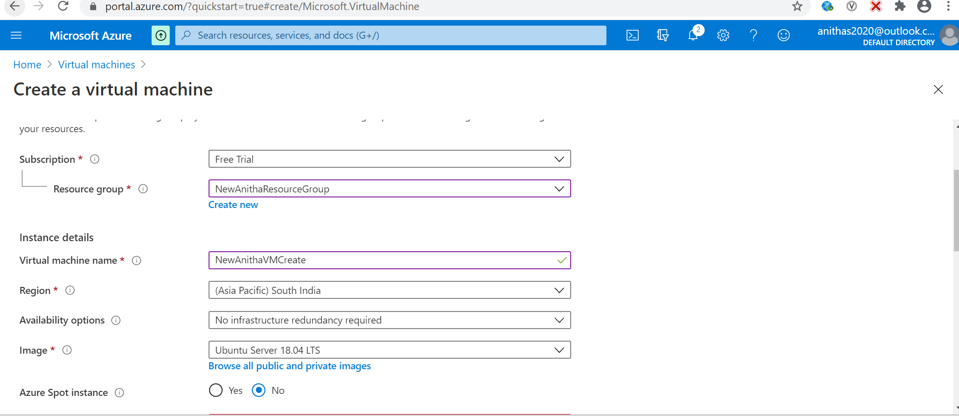

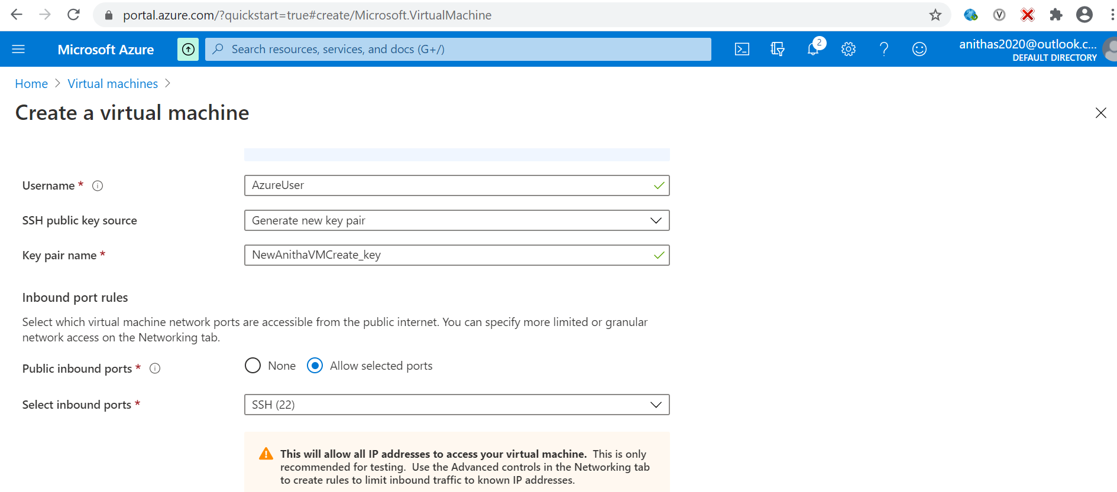

Azure App Services

1. Deploy a HTML Web Application in Azure App Services
2. Host the App Services in the Virtual Machine deployed

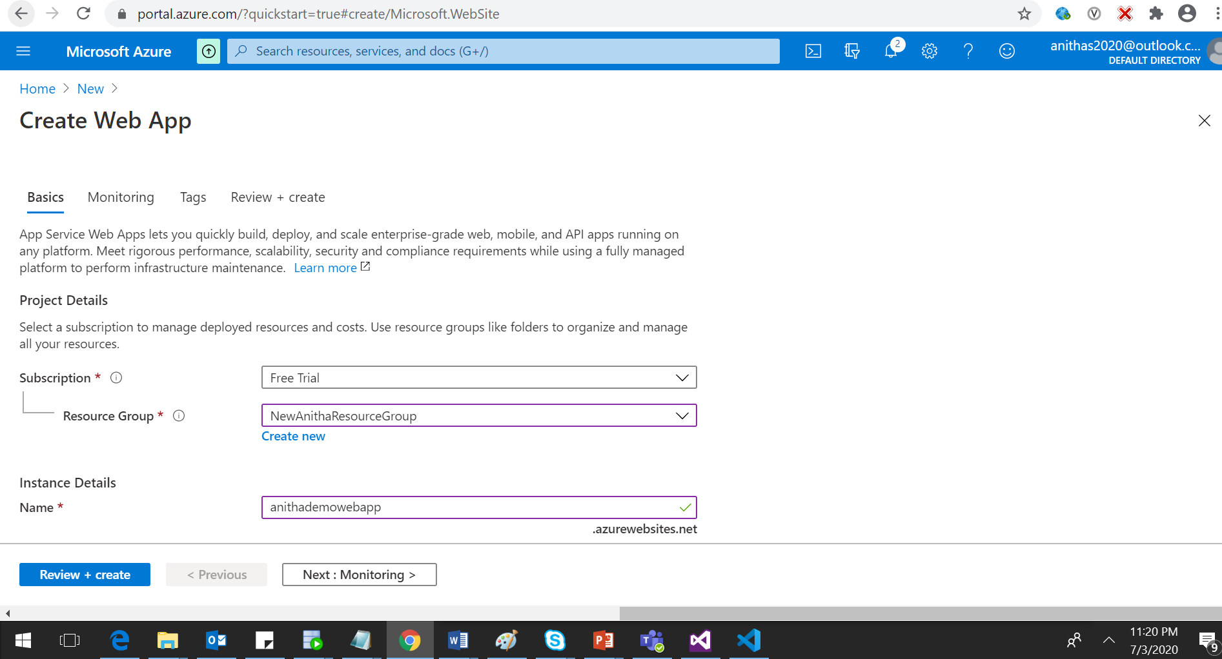

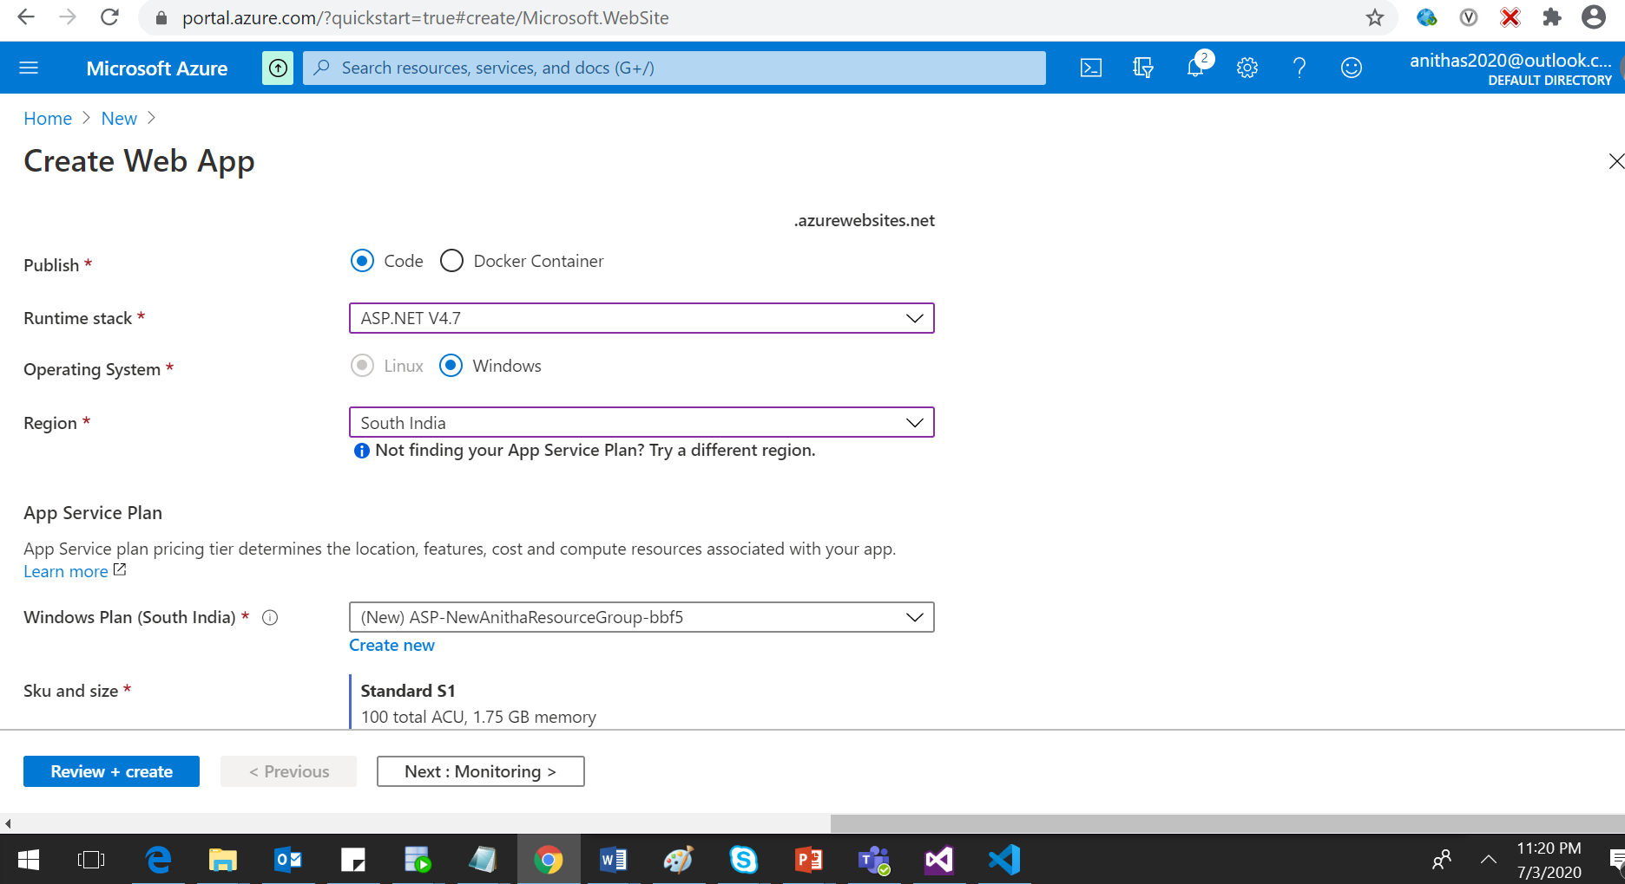

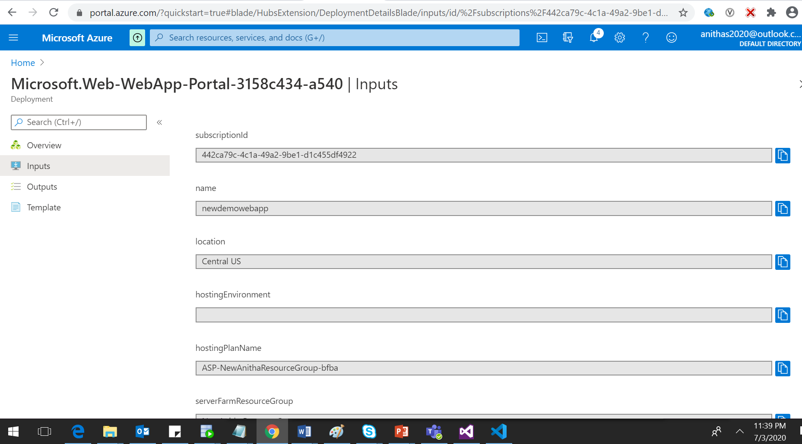

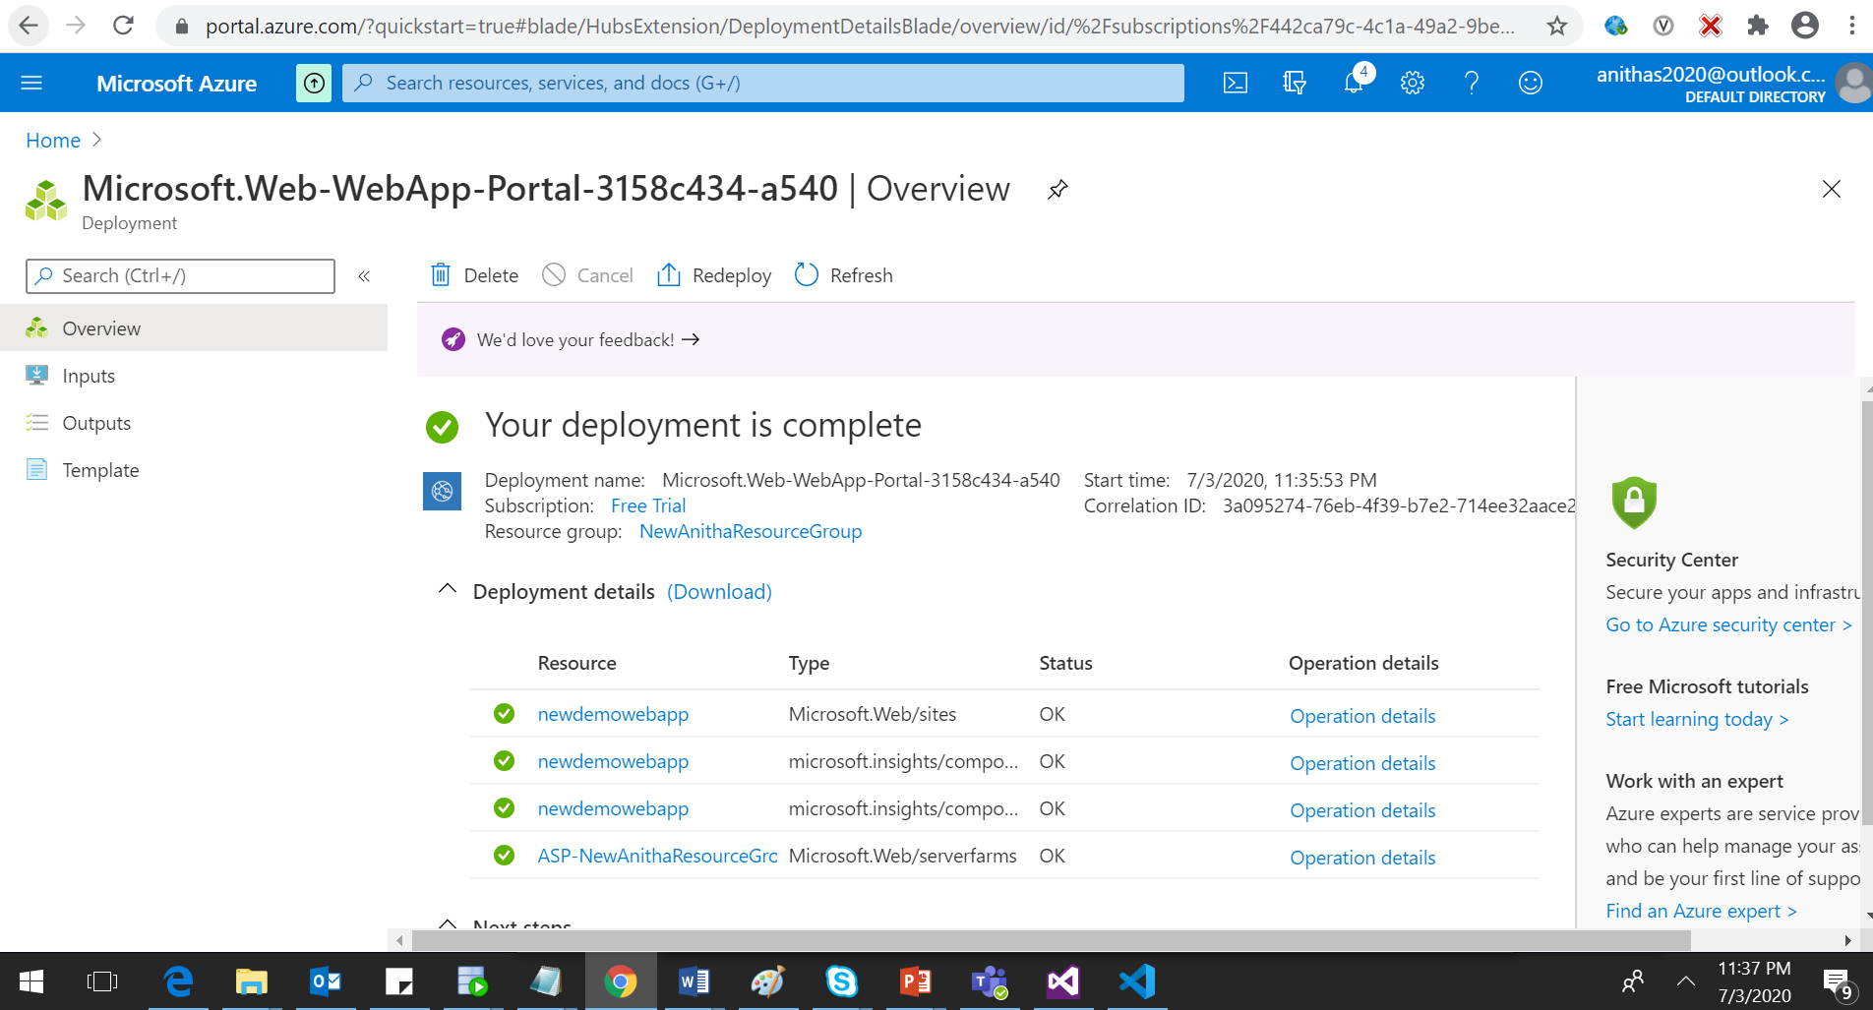

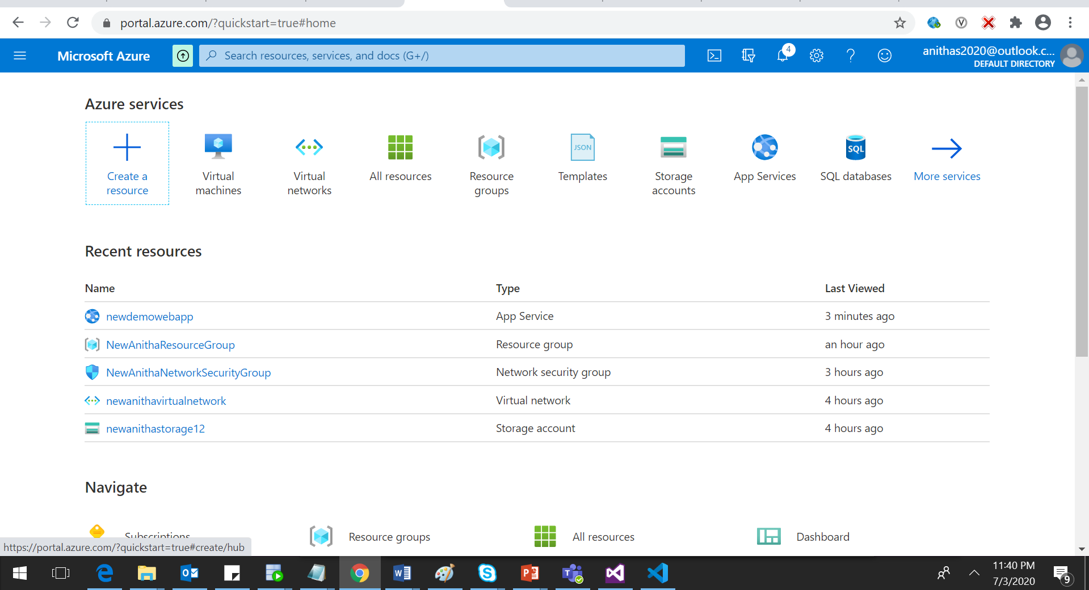

Azure Functions

1. Write an ARM Template to deploy the azure function along with the code and other required configurations.

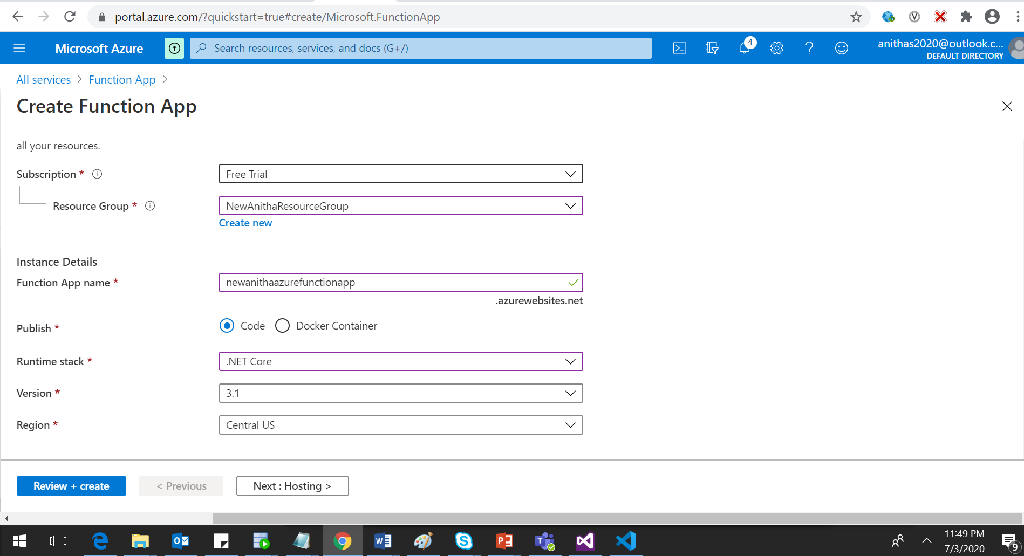

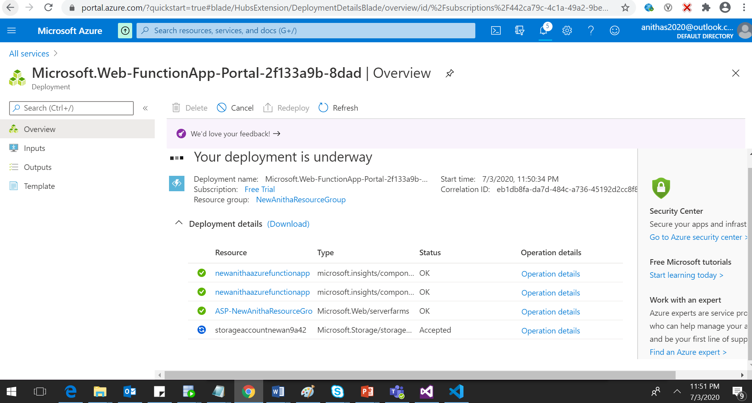

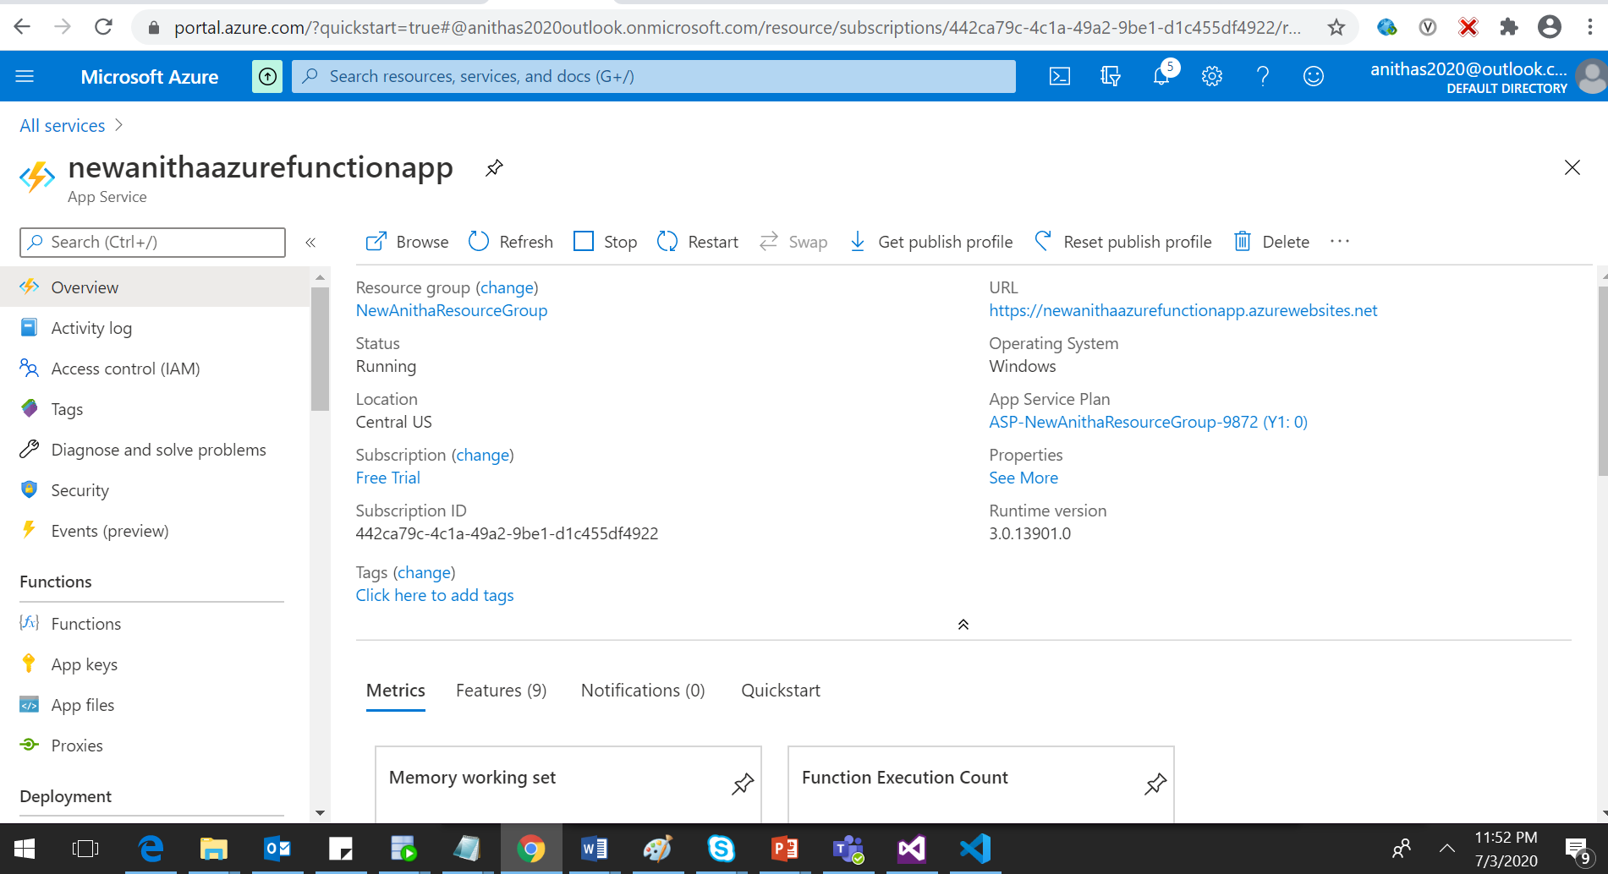

|  |
| --- |
| { |
|  | "name": "[concat(variables('functionsAppServiceName'), '/', variables('functionName'))]", |
|  | "type": "Microsoft.Web/sites/functions", |
|  | "apiVersion": "2015-08-01", |
|  | "properties": { |
|  | "config": { |
|  | "bindings": [ |
|  | { |
|  | "name": "myTimer", |
|  | "type": "timerTrigger", |
|  | "direction": "in", |
|  | "schedule": "[variables('functionSchedule')]" |
|  | } |
|  | ], |
|  | "disabled": false |
|  | }, |
|  | "files": { |
|  | "run.csx": "file-contents-goes-here" |
|  | } |
|  | }, |
|  | "dependsOn": [ |
|  | "[resourceId('Microsoft.Web/sites', variables('functionsAppServiceName'))]" |
|  | ] |
|  | } |

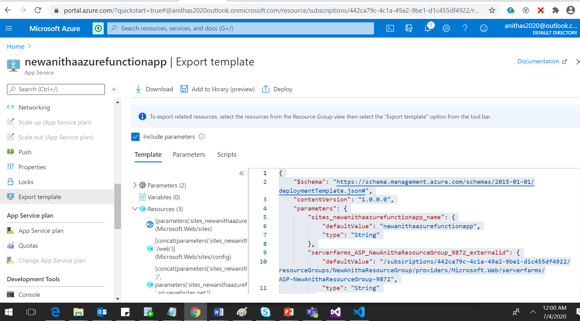

{

    "$schema": "https://schema.management.azure.com/schemas/2015-01-01/deploymentTemplate.json#",

    "contentVersion": "1.0.0.0",

    "parameters": {

        "sites_newanithaazurefunctionapp_name": {

            "defaultValue": "newanithaazurefunctionapp",

            "type": "String"

        },

        "serverfarms_ASP_NewAnithaResourceGroup_9872_externalid": {

            "defaultValue": "/subscriptions/442ca79c-4c1a-49a2-9be1-d1c455df4922/resourceGroups/NewAnithaResourceGroup/providers/Microsoft.Web/serverfarms/ASP-NewAnithaResourceGroup-9872",

            "type": "String"

        }

    },

    "variables": {},

    "resources": [

        {

            "type": "Microsoft.Web/sites",

            "apiVersion": "2018-11-01",

            "name": "[parameters('sites_newanithaazurefunctionapp_name')]",

            "location": "Central US",

            "kind": "functionapp",

            "properties": {

                "enabled": true,

                "hostNameSslStates": [

                    {

                        "name": "[concat(parameters('sites_newanithaazurefunctionapp_name'), '.azurewebsites.net')]",

                        "sslState": "Disabled",

                        "hostType": "Standard"

                    },

                    {

                        "name": "[concat(parameters('sites_newanithaazurefunctionapp_name'), '.scm.azurewebsites.net')]",

                        "sslState": "Disabled",

                        "hostType": "Repository"

                    }

                ],

                "serverFarmId": "[parameters('serverfarms_ASP_NewAnithaResourceGroup_9872_externalid')]",

                "reserved": false,

                "isXenon": false,

                "hyperV": false,

                "siteConfig": {},

                "scmSiteAlsoStopped": false,

                "clientAffinityEnabled": true,

                "clientCertEnabled": false,

                "hostNamesDisabled": false,

                "containerSize": 1536,

                "dailyMemoryTimeQuota": 0,

                "httpsOnly": false,

                "redundancyMode": "None"

            }

        },

        {

            "type": "Microsoft.Web/sites/config",

            "apiVersion": "2018-11-01",

            "name": "[concat(parameters('sites_newanithaazurefunctionapp_name'), '/web')]",

            "location": "Central US",

            "dependsOn": [

                "[resourceId('Microsoft.Web/sites', parameters('sites_newanithaazurefunctionapp_name'))]"

            ],

            "properties": {

                "numberOfWorkers": -1,

                "defaultDocuments": [

                    "Default.htm",

                    "Default.html",

                    "Default.asp",

                    "index.htm",

                    "index.html",

                    "iisstart.htm",

                    "default.aspx",

                    "index.php"

                ],

                "netFrameworkVersion": "v4.0",

                "phpVersion": "5.6",

                "requestTracingEnabled": false,

                "remoteDebuggingEnabled": false,

                "httpLoggingEnabled": false,

                "logsDirectorySizeLimit": 35,

                "detailedErrorLoggingEnabled": false,

                "publishingUsername": "$newanithaazurefunctionapp",

                "scmType": "None",

                "use32BitWorkerProcess": true,

                "webSocketsEnabled": false,

                "alwaysOn": false,

                "managedPipelineMode": "Integrated",

                "virtualApplications": [

                    {

                        "virtualPath": "/",

                        "physicalPath": "site\\wwwroot",

                        "preloadEnabled": false

                    }

                ],

                "loadBalancing": "LeastRequests",

                "experiments": {

                    "rampUpRules": []

                },

                "autoHealEnabled": false,

                "cors": {

                    "allowedOrigins": [

                        "https://functions.azure.com",

                        "https://functions-staging.azure.com",

                        "https://functions-next.azure.com"

                    ],

                    "supportCredentials": false

                },

                "localMySqlEnabled": false,

                "ipSecurityRestrictions": [

                    {

                        "ipAddress": "Any",

                        "action": "Allow",

                        "priority": 1,

                        "name": "Allow all",

                        "description": "Allow all access"

                    }

                ],

                "scmIpSecurityRestrictions": [

                    {

                        "ipAddress": "Any",

                        "action": "Allow",

                        "priority": 1,

                        "name": "Allow all",

                        "description": "Allow all access"

                    }

                ],

                "scmIpSecurityRestrictionsUseMain": false,

                "http20Enabled": false,

                "minTlsVersion": "1.2",

                "ftpsState": "AllAllowed",

                "reservedInstanceCount": 0

            }

        },

        {

            "type": "Microsoft.Web/sites/hostNameBindings",

            "apiVersion": "2018-11-01",

            "name": "[concat(parameters('sites_newanithaazurefunctionapp_name'), '/', parameters('sites_newanithaazurefunctionapp_name'), '.azurewebsites.net')]",

            "location": "Central US",

            "dependsOn": [

                "[resourceId('Microsoft.Web/sites', parameters('sites_newanithaazurefunctionapp_name'))]"

            ],

            "properties": {

                "siteName": "newanithaazurefunctionapp",

                "hostNameType": "Verified"

            }

        }

    ]

}

Azure Cosmos DB

1. Write an ARM Template to deploy all the Cosmos DBs

2. Integrate the above deployed Azure function with all the Cosmos DB and retrieve the logs

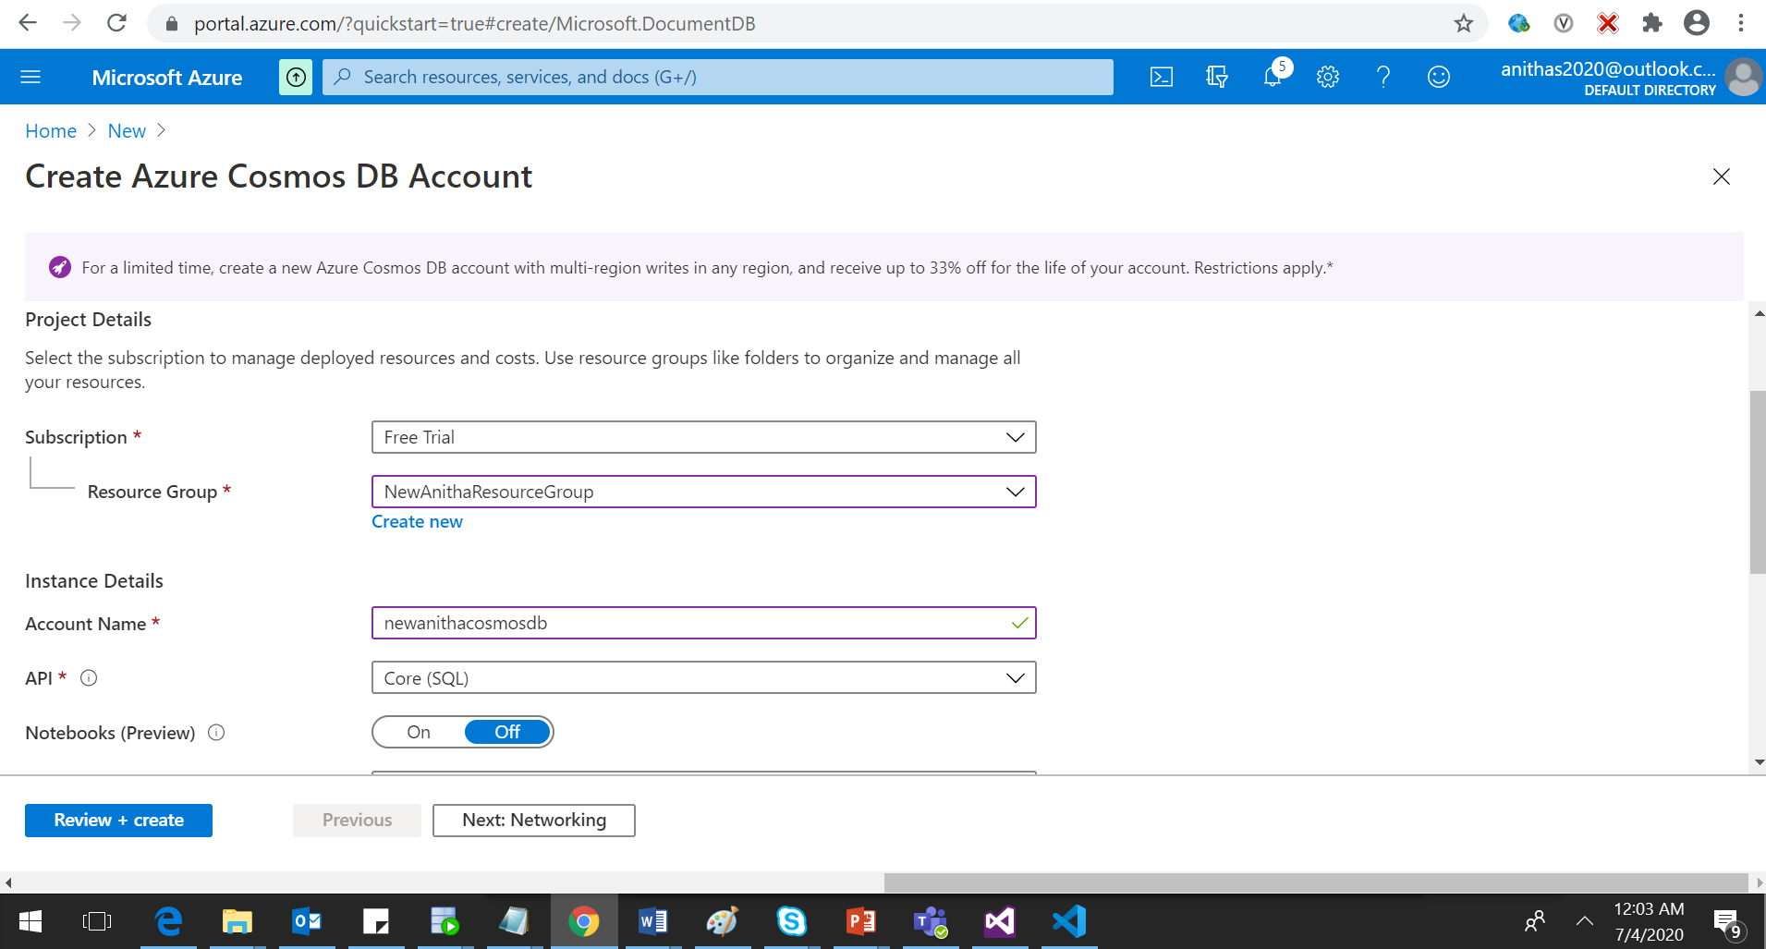

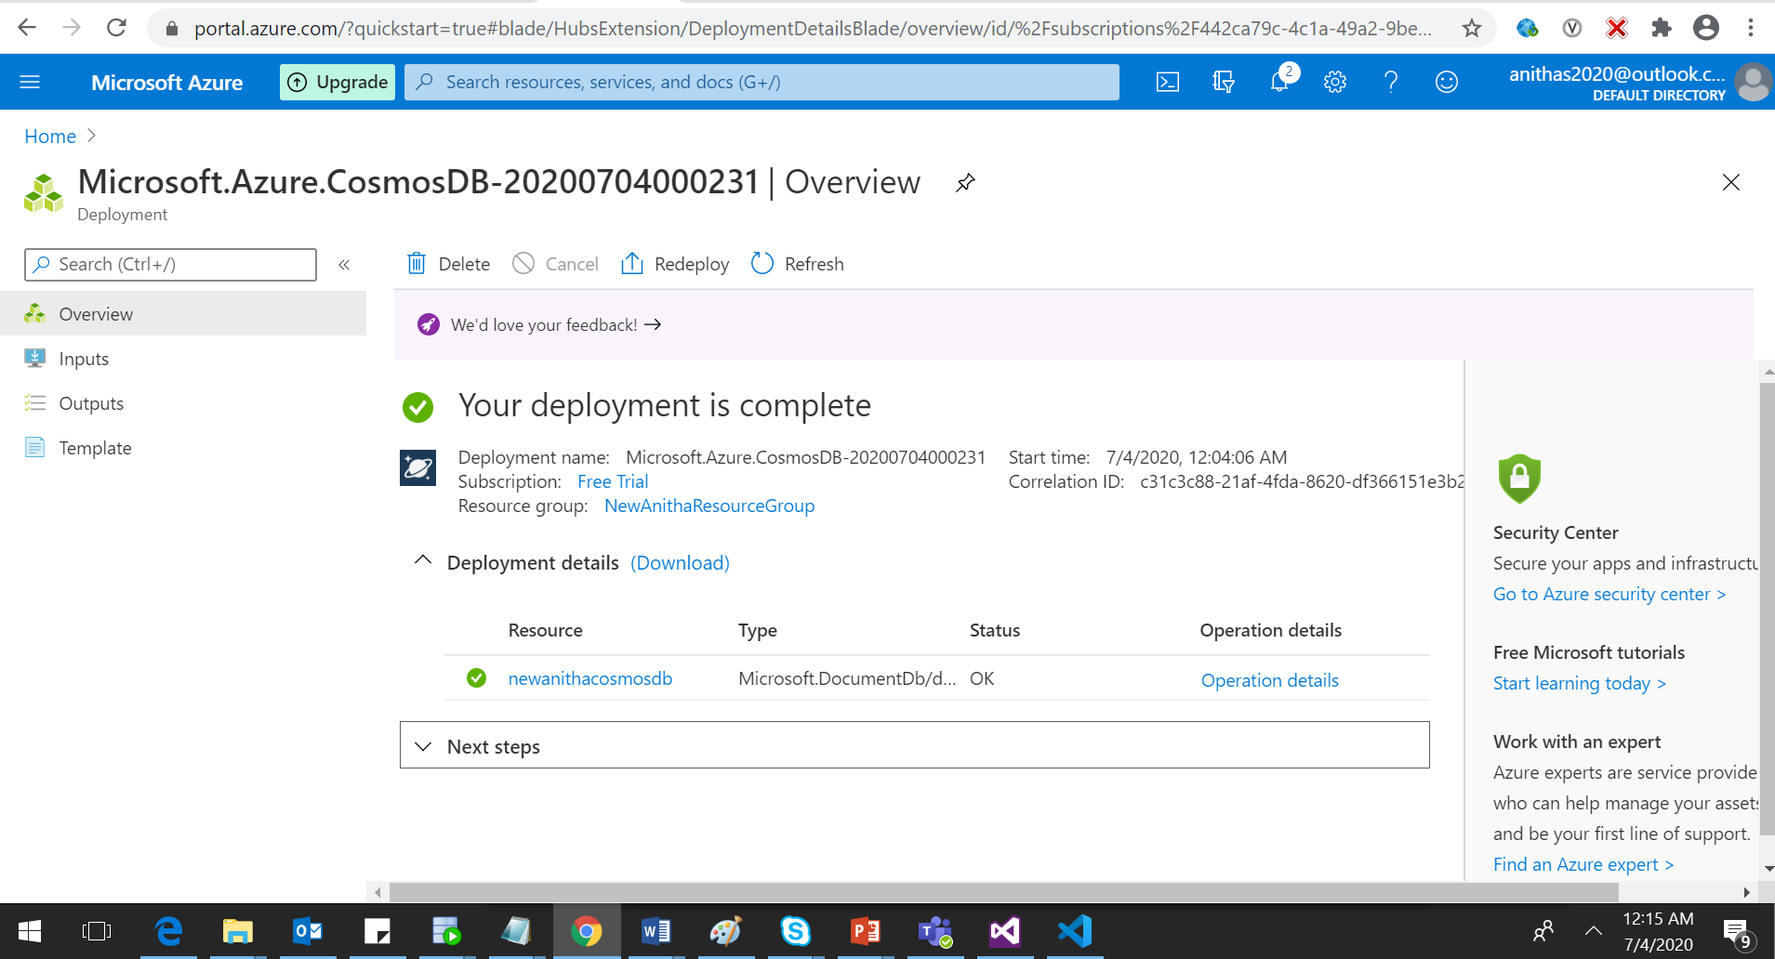

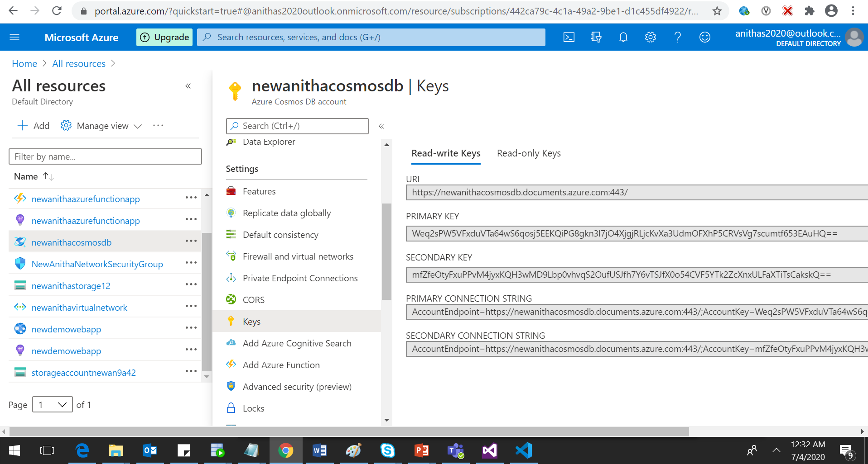

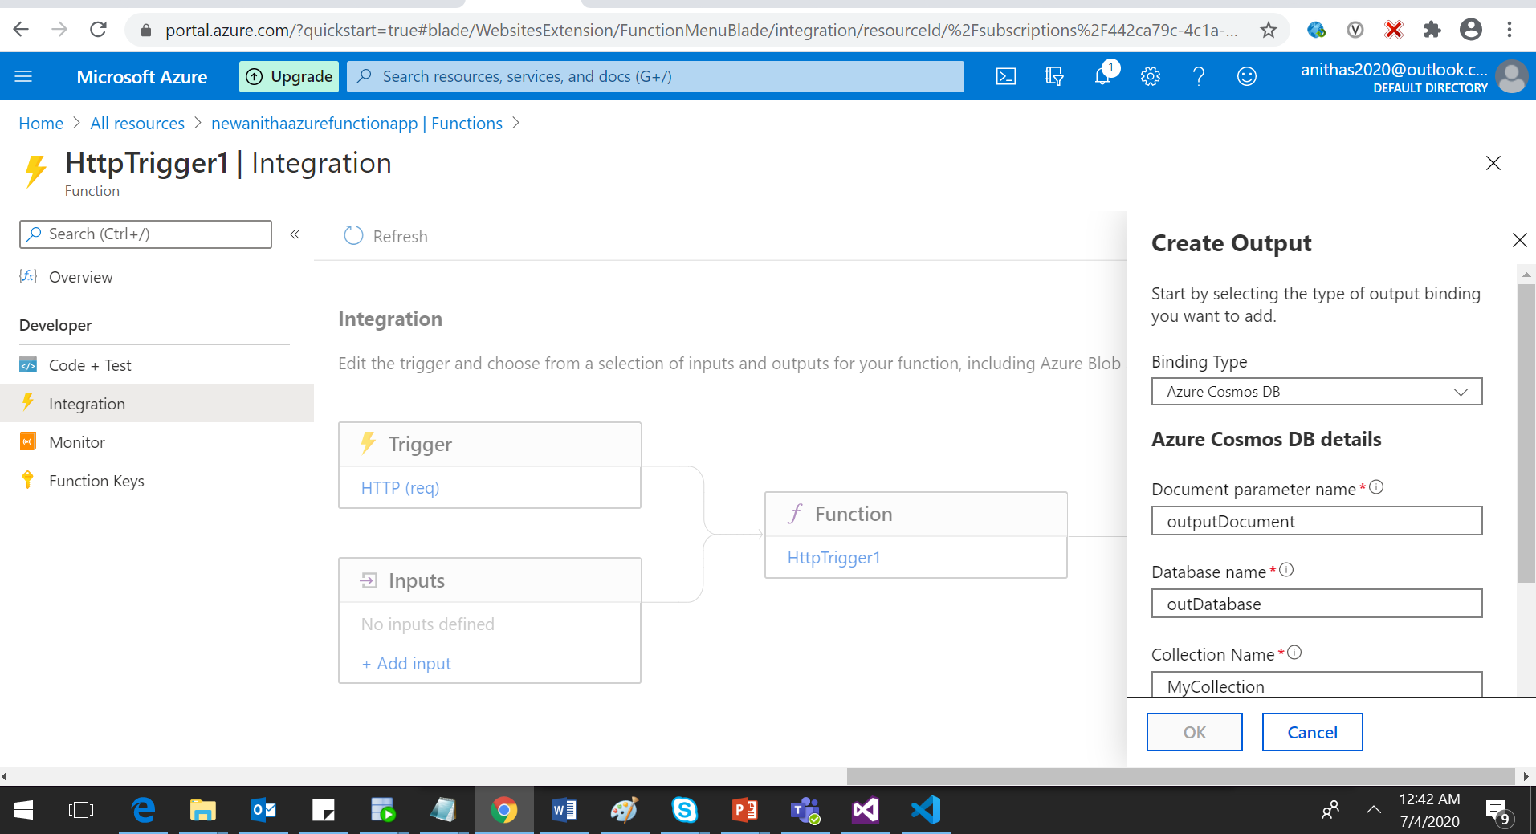

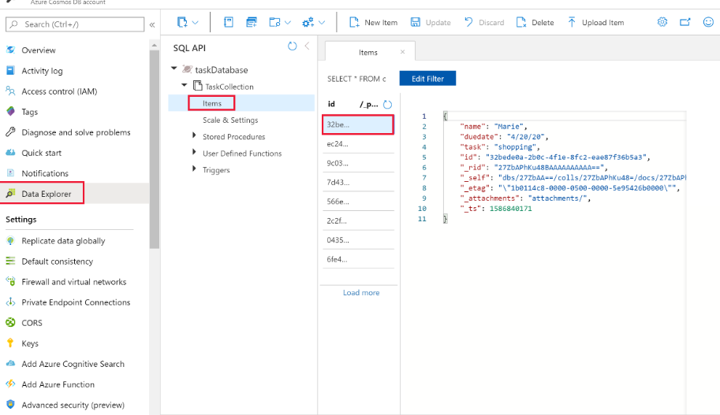

Azure Active Directory

1. Write a client application to authenticate based on OAuth grant flow.

